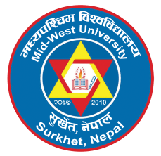 | MID-WEST UNIVERSITY  OFFICE OF THE DEAN  GRADUATE SCHOOL OF MANAGEMENT  Birendranagar, Surkhet, Nepal  Eligibility Criteria for Admission
Criteria | Programs
Criteria | MPhil | PhD
- Academic qualification | Master’s degree in management with at least 50% or 2.50/4.00 CGPA. | MPhil in management with at least 60% or 3.00/4.00 CGPA.
- Work experience | - No work experience required for at least 80% or 3.50/4.00 CGPA in master’s degree.  - One-year post-master’s degree work experience required for  at least 60% or 3.00/4.00 CGPA in master’s degree.  - Two-year post-master’s degree work experience required for at least 50% or 2.50/4.00 CGPA in master’s degree.
- Academic publications |  | At least 2 articles published in peer review journals

